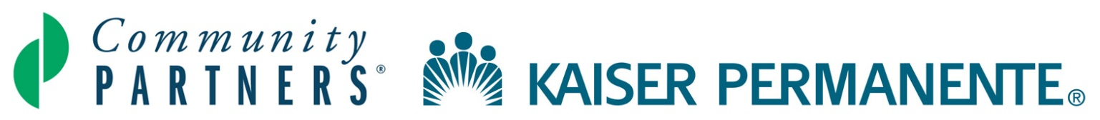

HEAL Fall 2017 Network Leaders Learning Circle
Thursday, November 2, 2017 | California Endowment | 10:00 am – 3:00 pm

The format for this Learning Circle will be an “Action Learning Workshop” - a participatory meeting which integrates learning from the field on key practices and principles for maintaining momentum and achieving sustainability, along with group brainstorming and small team activities. The overall goal of the session is to have an in-depth conversation about the lessons from the field and create guideposts and action plans for the future of HEAL.
OBJECTIVES
- Learn about and celebrate the successes that have come from strong partnerships
- Understand long-term lessons of place-based initiatives
- Prepare for sustained commitment to HEAL communities

AGENDA

10:00 – 10:15 am | Welcome, Introductions, Icebreaker and Framing  Judy Harper, Community Partners
10:15 – 11:00 am | Celebrating Success and Partnerships  Letty Alvarez, West Ventura HEAL Local Partnership  Shené Bowie-Hussey and Jesika Aboagye, East Riverside HEAL Zone  Anita Lopez and Angeles Nelson, Lemon Grove HEAL Zone  Viki Gutierrez, North Long Beach HEAL Zone  Rapid-Fire Presentations will highlight examples of strong and innovative partnerships from our HEAL communities.
11:00 am – 11:45 am | Building Enduring Partnership Platforms:  3 Proverbs and 3 Lessons About Sustainability and Endurance  Jennifer Vanica, VanicaCummings Consulting
11:45 am – 12:15 pm | Discussing HEAL Communities:  Where’s our momentum and what are our challenges?  A large group discussion that will aim to take us beyond “how do we replace our HEAL grant?”!
12:15 – 12:30 pm | Break/Grab Food for Working Lunch
12:30 – 2:00 pm | Sustainability: The What, the Why and the How  Table breakouts – Here’s where the hard work comes in!
2:00 – 2:15 pm  2:15 – 2:45 pm  2:45 – 3:00 pm | Break  Endurance: 3 Big Ideas  Table breakouts – What do we want to endure and why?!  Reflections and Next Steps

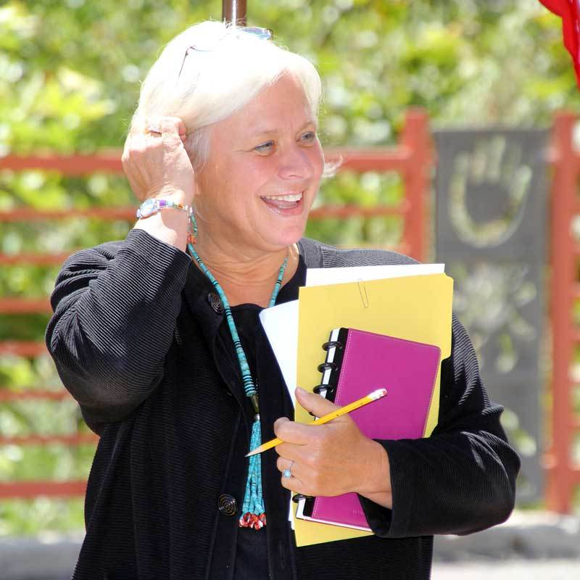

Jennifer Vanica
jennifer@vanicacummings.com

In 2015, I was appointed a Senior Fellow at PolicyLink — an organization guided by the belief that those closest to the nation’s challenges are central to finding solutions. They are also dedicated to “lifting up what works.” In that role, I am bringing forward the stories, lessons, strategies and structures we have used to capture the power and capacity of people to create and own change.

I am a deep believer in equity and inclusion, and I have always pursued opportunities to advance social justice. This commitment was shaped during the late 1960’s when I worked side-by-side with farmers in Kentucky’s Appalachian farmlands, native Americans building schools on Wyoming’s reservations, and the Cesar Chavez and the Mexican American Farmworker Union organizing boycotts for better working conditions in California.
For the next 15 years, I worked raising money to strengthen access to higher education, served on the start-up team for a major healthcare foundation, and led a $17 million public-private campaign to build a critically-needed 103-bed emergency shelter for children in San Diego.

With the launch of VanicaCummings in the early 1990s, my work focused on fundraising and capital campaign planning, non-profit strengthening, and providing technical assistance in partnership with foundations that wanted to strategically link capacity building to grantmaking.

In 1995, Ron and I would put our business on hold to become the leadership team of a newly created operating foundation, called the Jacobs Center for Neighborhood Innovation, to address the underlying issues of disinvestment and economic distress in a disinvested area of San Diego. The community partnership would become known as the “Market Creek experience.”

For the next 16 years, I served as the President & CEO of the Jacobs Center and worked alongside more than 3,000 community residents to transform blight, bring the community its first full-service grocery, build a science institute with and for young people, create jobs, restore a toxic waterway, support entrepreneurship, improve public safety, create a vibrant cultural village, and buy stock in their project.

I have served as an Aspen Institute Senior Fellow, MIT research associate, an advisory team member for HUD’s National Revitalization Initiative, and have been involved in numerous case studies and articles, including USC’s recent “State of Place-Based Philanthropy and Public Policy,” and Aspen’s “Complexity and Community Change.” I am currently in the process of writing a book on the lessons of leading comprehensive community change.

